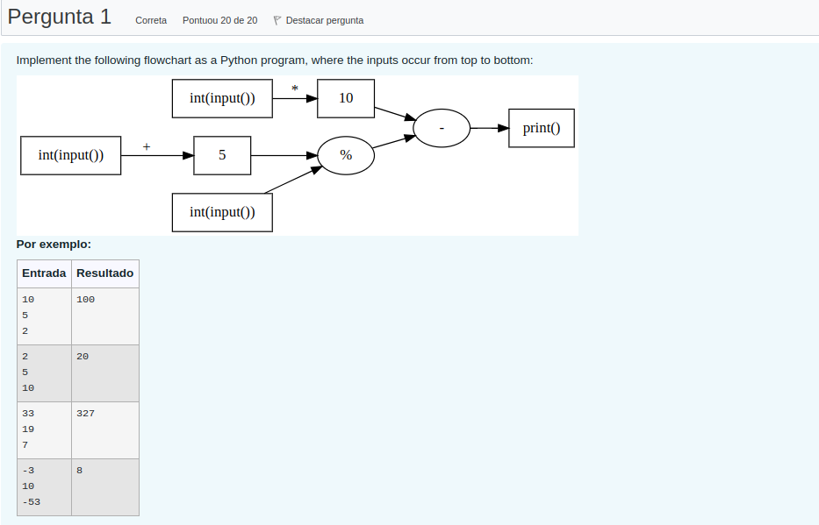
Feigfd

Pergunta 2

The Body-mass index (BMI) of an individual is a measure of weight (in Kg) relation to height (in meters) and is computed as BMI = weight / height**2. This measure can be used to classify an individual:

Underweight | < 17.0
Mild Underweight | [17.0, 18.5[
Normal | [18.5, 25.0[
Overweight | [25.0, 30.0[
Obese | ≥ 30.0

Write a function classify(weight, height) that computes the BMI for an individual given the weight and height and returns a string 'underweight', 'mild_underweight', 'normal', 'overweight' or 'obese'.

Por exemplo:
Teste | Resultado
print(classify(75, 1.75)) | normal
print(classify(78, 1.65)) | overweight
print(classify(50, 1.65)) | mild_underweight
print(classify(90, 1.65)) | obese

Pergunta 3

Write a function compute_euler(n) that given a positive integer n, computes the approximation of e using the following truncated series sum, from 0 to n:

e≈∑nk=01k!

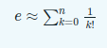

where k!=1×2×⋯×(k−1)×k is the factorial of k (see math.factorial).
By taking larger values of n we can obtain better approximations.
Use round to approximate the result to 5 decimal places.
Por exemplo:
Teste | Resultado
print(compute_euler(50)) | 2.71828
print(compute_euler(5)) | 2.71667
print(compute_euler(0)) | 1.0
print(compute_euler(1)) | 2.0

Pergunta 4

Write a function primes_difference(n) that given a positive integer n, where n > 3, returns the difference between the first prime number greater than n and the first prime number smaller than or equal to n.

A prime number is a natural number greater than 1 that can only be divided by 1 or itself.

For example, for n=45, the function returns 4 = (47-43).
Hint: Write a boolean function is_prime(n) to check whether a number n is prime or not.

Por exemplo:
Teste | Resultado
print(primes_difference(74)) | 6
print(primes_difference(60)) | 2
print(primes_difference(10)) | 4
print(primes_difference(193)) | 4

Pergunta 5

Decimal numbers are base 10 numbers that use only digits from 0 to 9, inclusive.
Senary numbers are base 6 numbers that use only digits 0, 1, 2, 3, 4 and 5.
Write a Python program that converts a senary number (base 6) senary, given by user input, into the corresponding decimal number (base 10).

For example:
- for senary=11, the output is the decimal number 7 (because 1*6**1+1*6**0 = 7)
- for senary=125, the output is the decimal number 53 (because 1*6**2+2*6**1+3*6**0 = 53)
- for senary=1543, the output is the decimal number 423 (because 1*6**3+5*6**2+4*6**1+3*6**0 = 423)

Por exemplo:
Entrada | Resultado
11 | 7
125 | 53
1543 | 423
12345 | 1865

